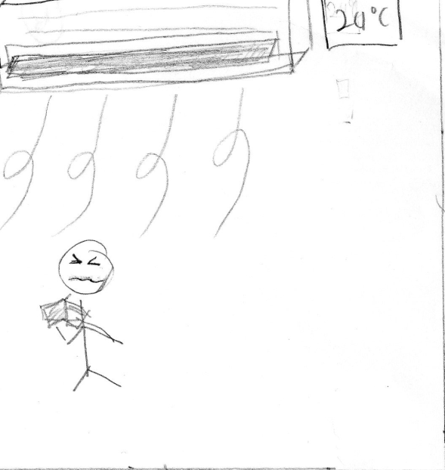

1.Student Is studying in an air conditioned room set to 24 Celsius. The student starts to feel cold but is too focus to realise that the temperature of the room is too cold.

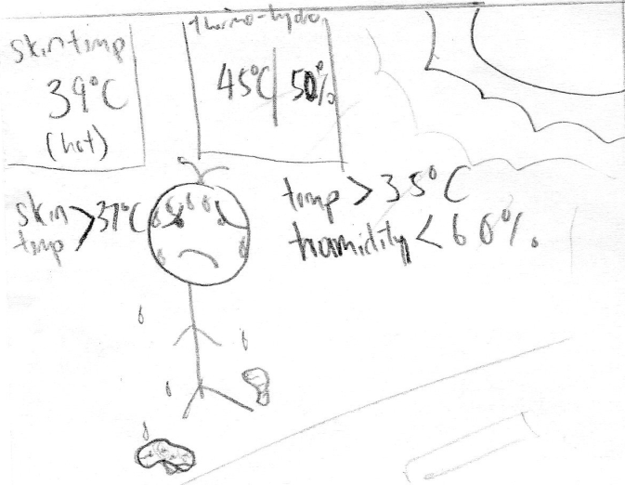

4.Student after finish studying walks back home under the hot scorching sun. The app detected that the student skin temperature rises to 39 Celsius, thermos-hygrometer temperature more than 35 Celsius and the humidity lower than 60%.

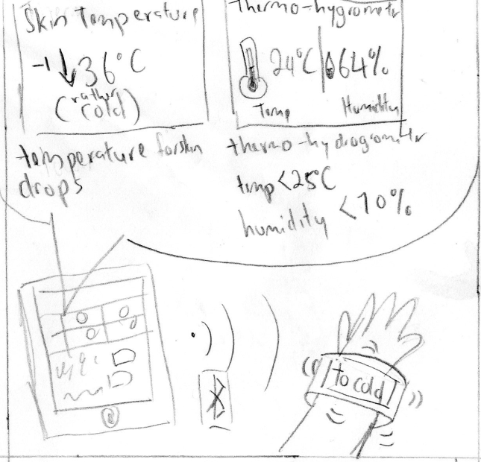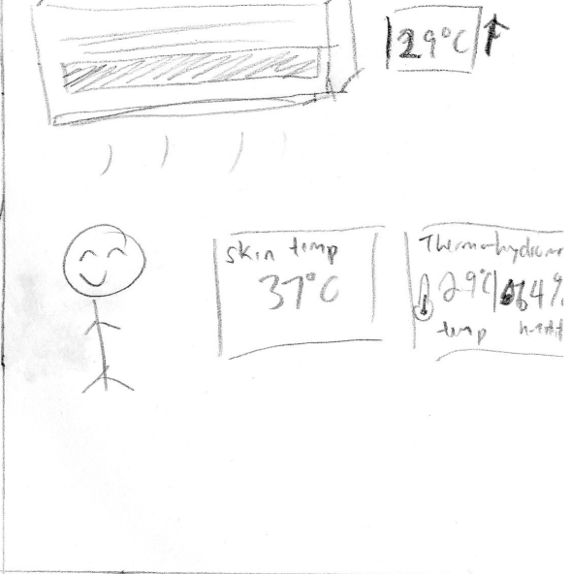

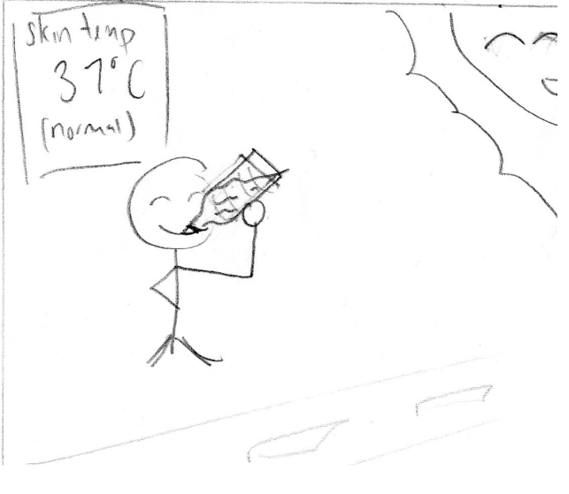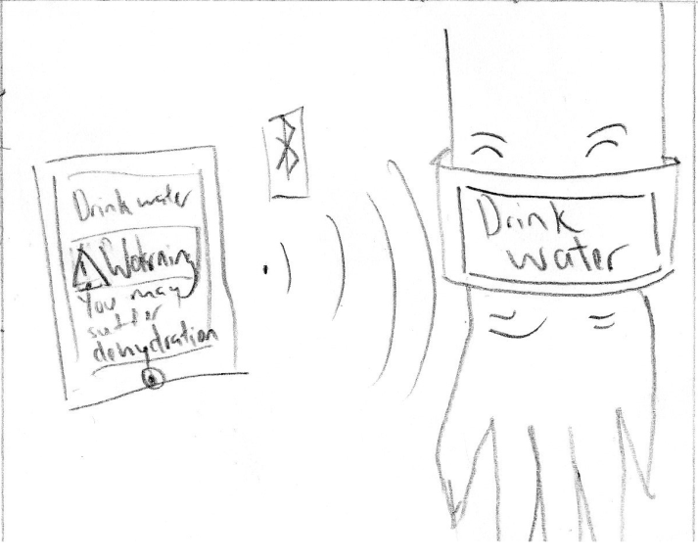2.The FitHealth app analyses the data sent from wristband. When the skin temperature starts to drop and the Thermo-hydrometer temperature is lower than 25 Celsius and the humidity is lower than 70%, it will instruct the wristband to vibrate and display onscreen “too cold” via Bluetooth.

5.The app displays a warning on the tab screen that student is in danger of being dehydrated. At the same time it sends a signal to the wristband to vibrate and display onscreen to “drink water” via Bluetooth .

3. The student then realises the air conditioning temperature is low and increases the temperature of the room. This allows the student to comfortably continue studying as the FitHealth apps then detects the student’s skin temperature revert to normal temperature of 37 Celsius.

6.Student is then notified and proceeds to drink water. The water cools down the internal body temperature which in turn cools down the skin temperature of the body back to 37 Celsius.

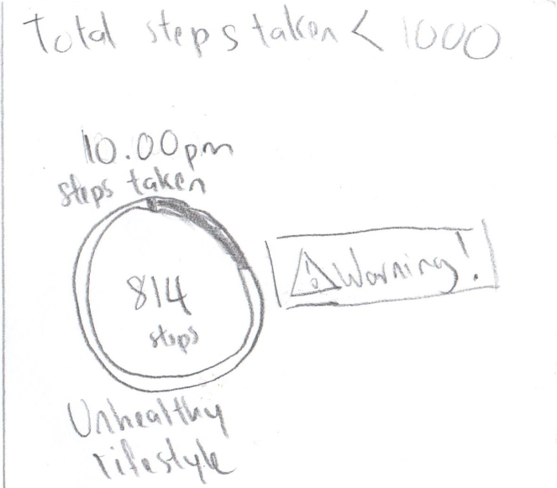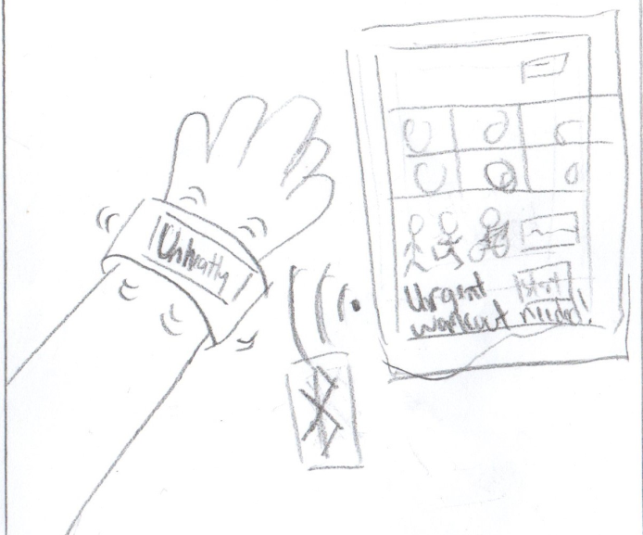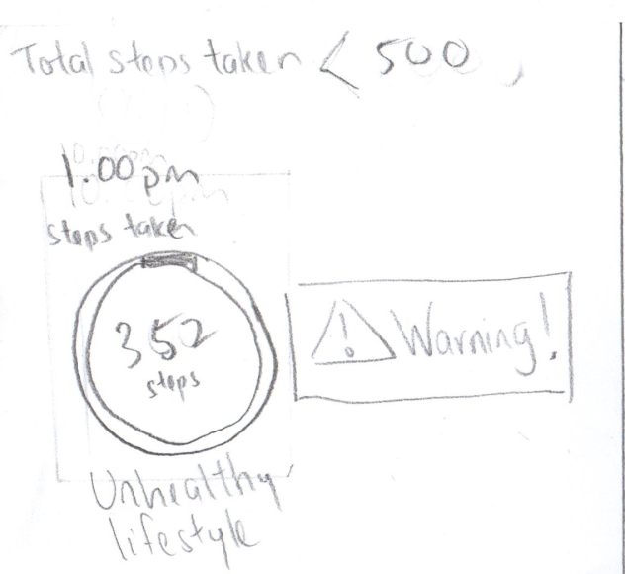

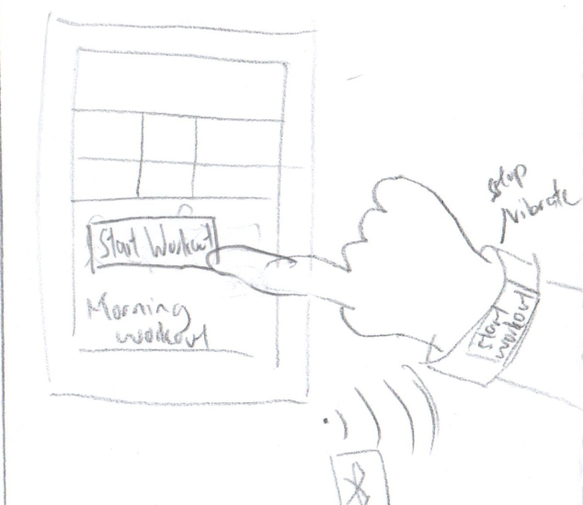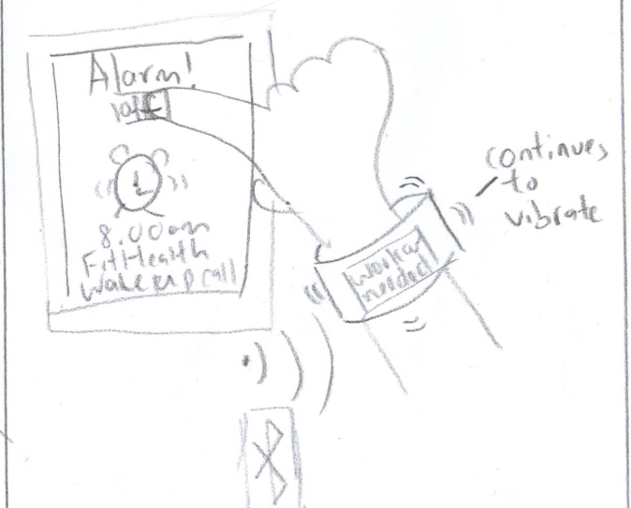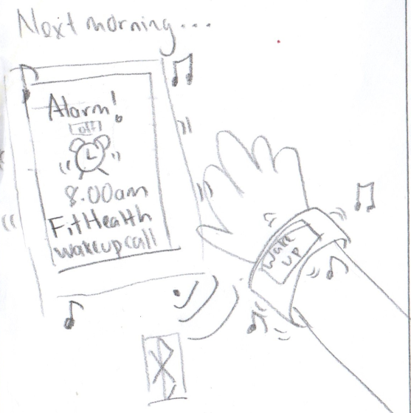

1.The student was indoor whole day playing games. By 1pm afternoon the number of steps taken that day is less than half of the number of steps goal set by the student . The app analyses this data as unhealthy lifestyle.

4.This causes the app to auto set an alarm 1 hour earlier than the student’s average wake up time . When the alarm rings it also causes the wristband to vibrate and plays some music to make sure the student wakes up on time via Bluetooth.

2.The app on the tablet sends signal to the wristband to vibrate and inform student onscreen “unhealthy” to remind the student to workout.

5.The wristband will stop playing music but will continue vibrating and also display onscreen to remind student that “workout needed”.

3.The student continues playing games and only occasionally goes out to eat. By night time, the app records that the students did not reach the number of steps taken goal.

6. The wristband will only be signal to stop vibrating once the student starts the workout.

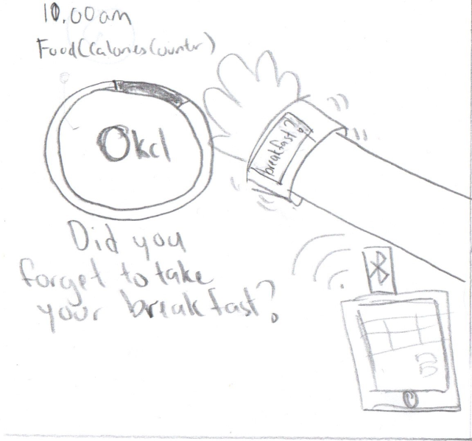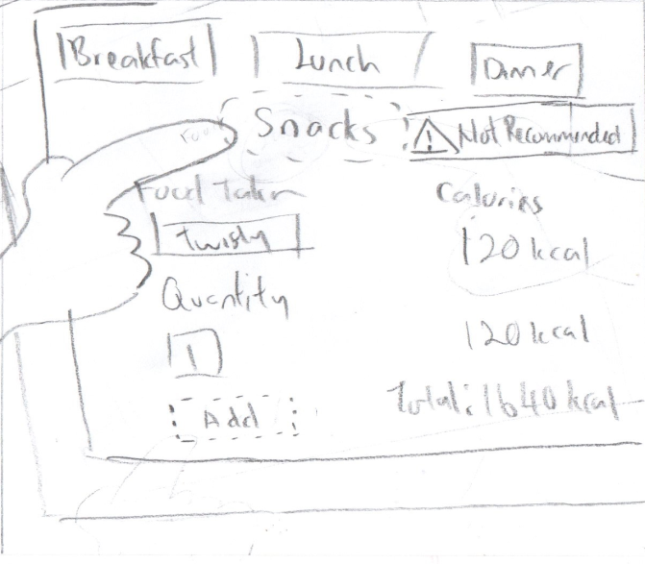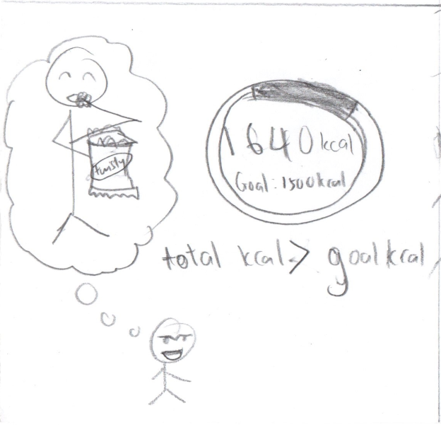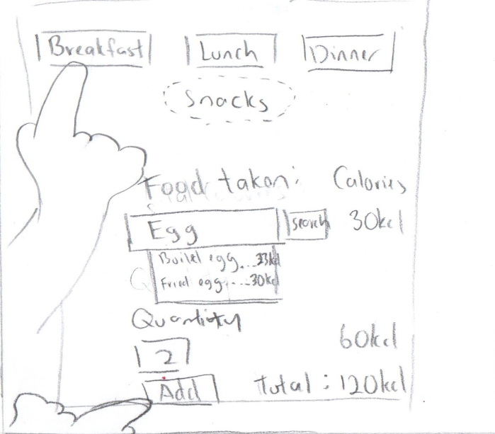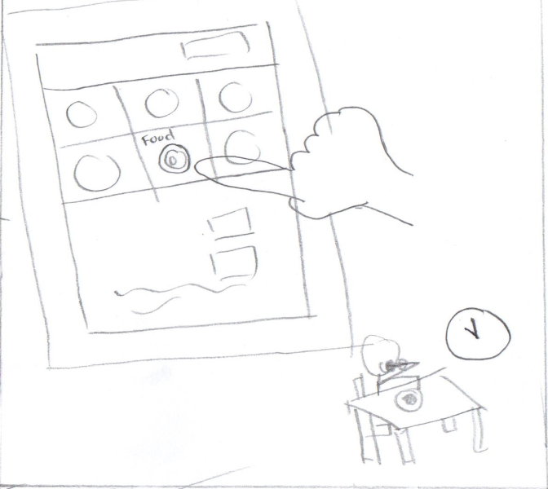

1.The Student was rushing to class and forgotten to eat breakfast. At 10am the app will signal for the wristband to vibrate and display onscreen “breakfast” reminder , if the total calories is still 0kcl.

4.Some time in the evening, the student had a sudden cravings to eat some twisty. The intake of calories for the day exceeds the calorie goal suited to the student.

2.When the student has finally eaten his/her breakfast, the Student clicks on the calorie counter to record his/her meal.

5. The student access the calorie counter to check the total calories of a bag of twisties. The app detecting that the total intake of calories is more than the calorie goal, Displays warning beside the snack option that it is not recommended when clicked.

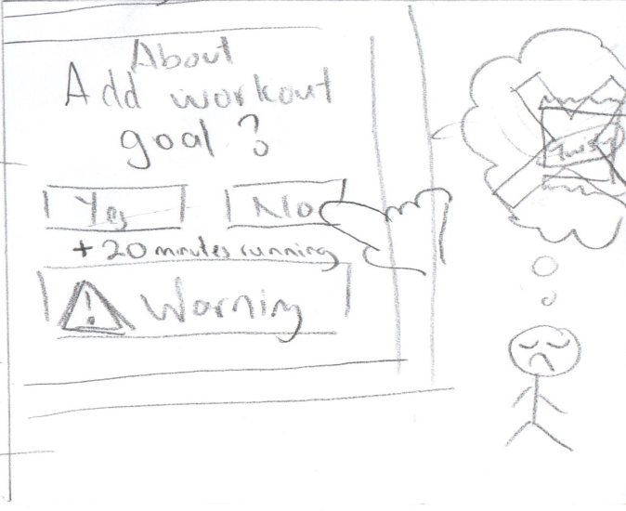3.The window for the calorie counter is displayed. The student then selects breakfast and keys in food that he/she ate for breakfast and the quantity. The app calculates the calories of the meal and records it down when confirms the add.

6. Before the add can be confirmed, a warning message is displayed to inform student that consuming the twisties would require a 20 minutes extra run to stick to the calories intake. The student chooses not to eat the twisty to avoid adding extra workout.

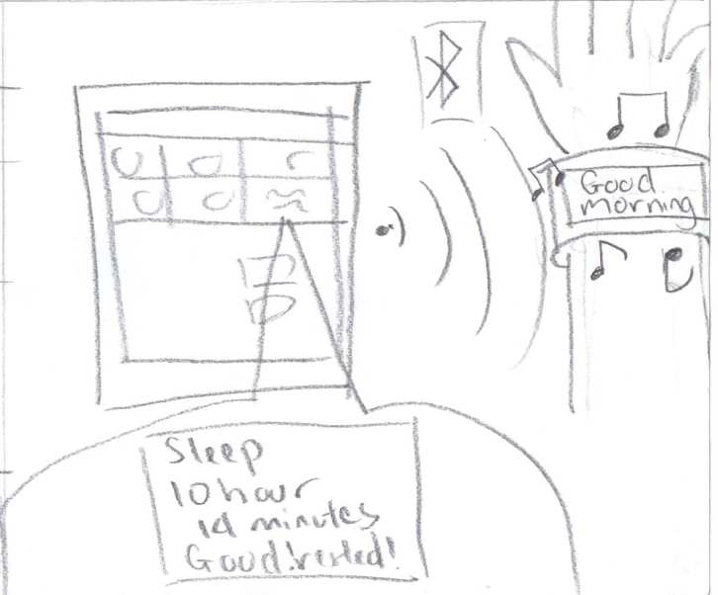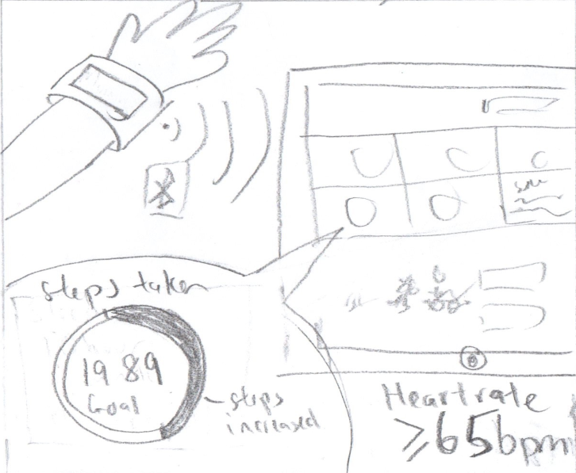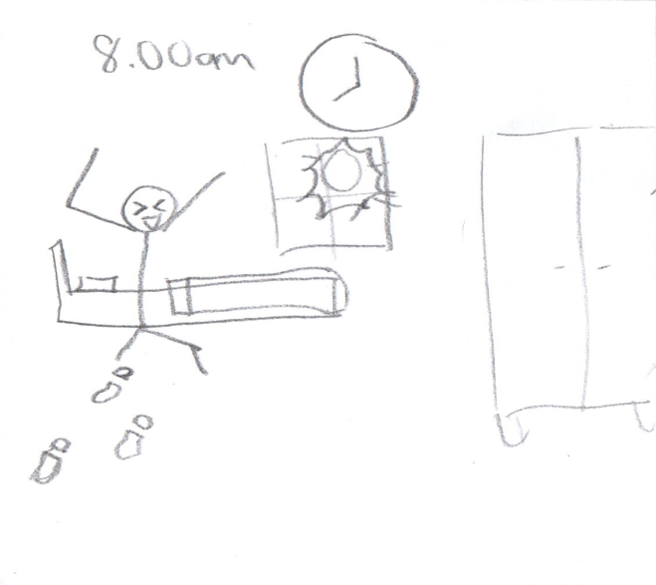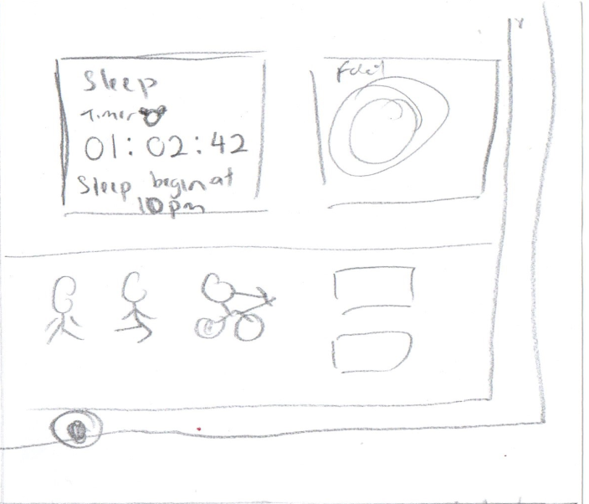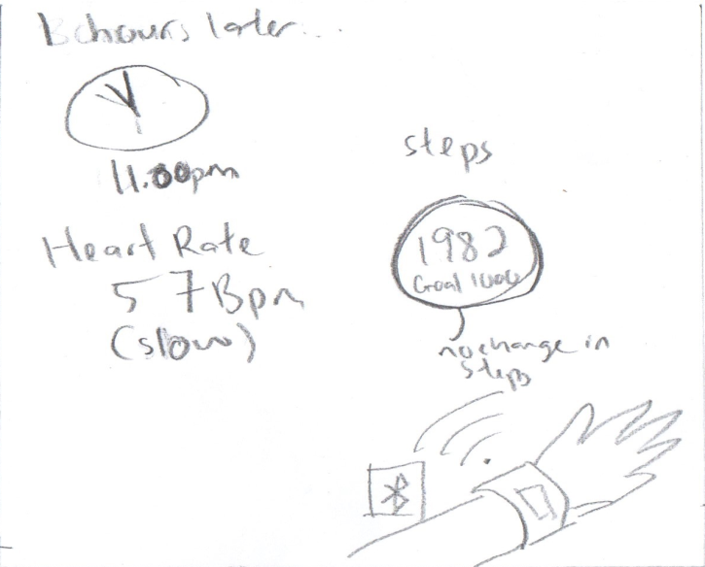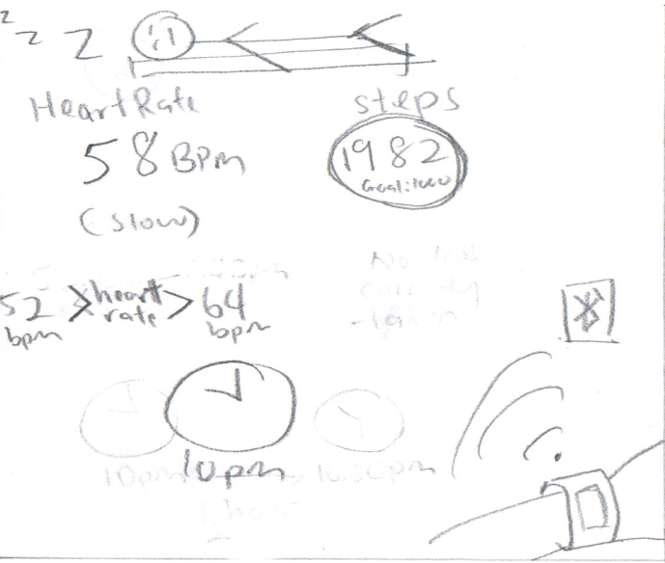

1.At 10pm the student goes to sleep .The wristband sends the data of the student’s heartrate and steps taken to the app in the tablet. Where the heart rate is between 52 to 64 bpm and a total of 1982 steps taken.

4.The next morning , the student rises up at 8am in the morning. The student gets out of bed and starts to walk towards the window.

2.After 1 hour the wristband detects no changes in number of steps taken and the heartbeat is still in between the range of 52 to 64 bpm. The application analyses and concludes that student is asleep.

5.The wristband detects the increase in steps taken and heart beat and the data is sent to the app. The app then analyse that the steps taken have increased and the heart rate of student is not more than 65 bpm . The app then stops the sleep timer.

3. The sleep timer is then started on the application from the time the heart rate was between 52 bpm to 64 bpm and steps taken did not change.

6. The apps displays the number of hours the student slept. At the same time it sends signal to the wristband to play a short tune and display onscreen “good morning”

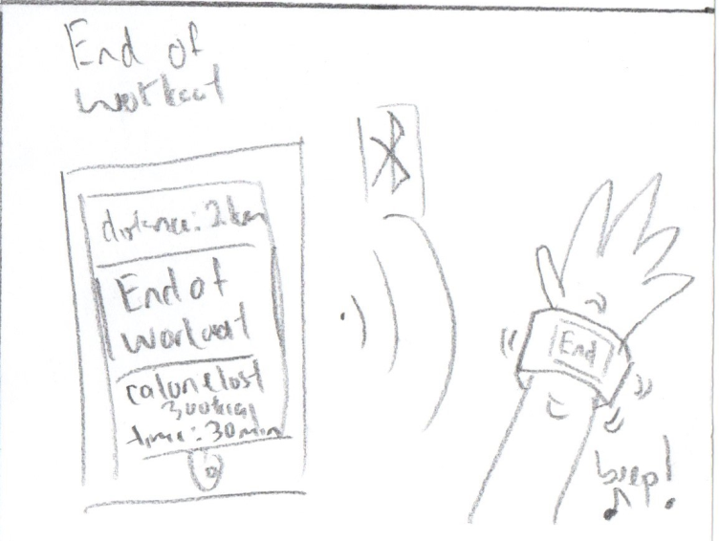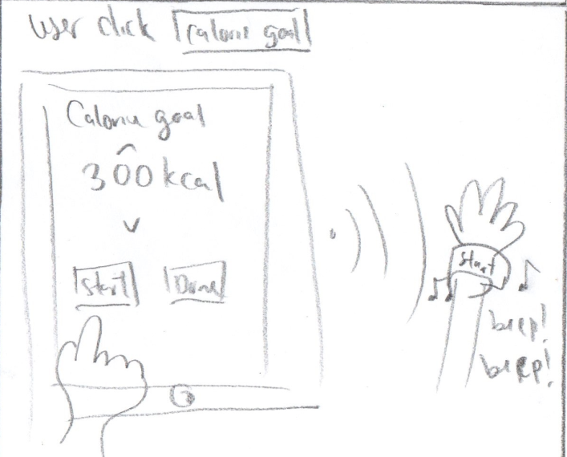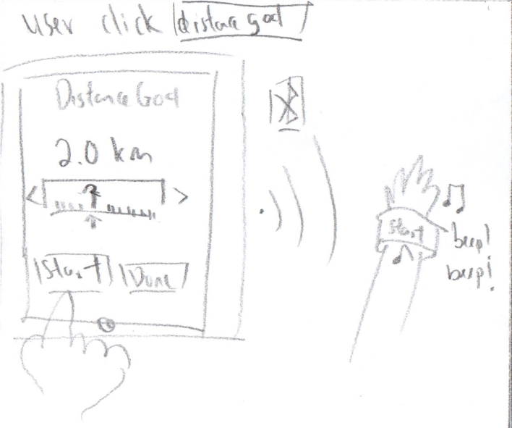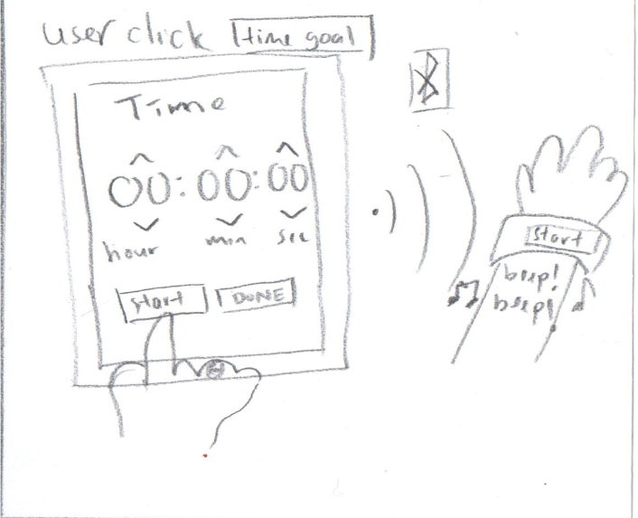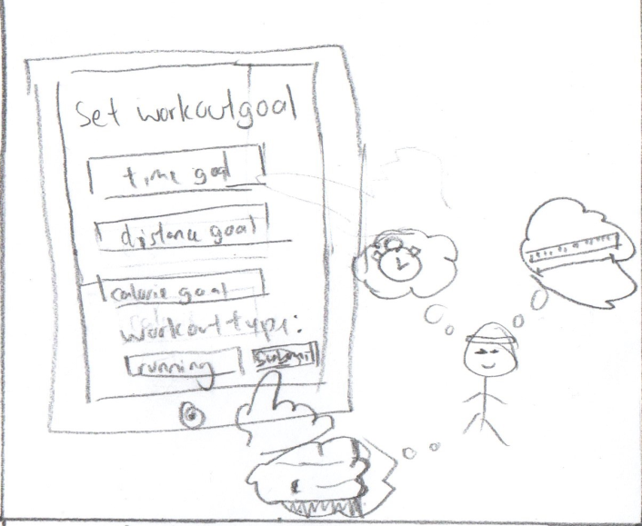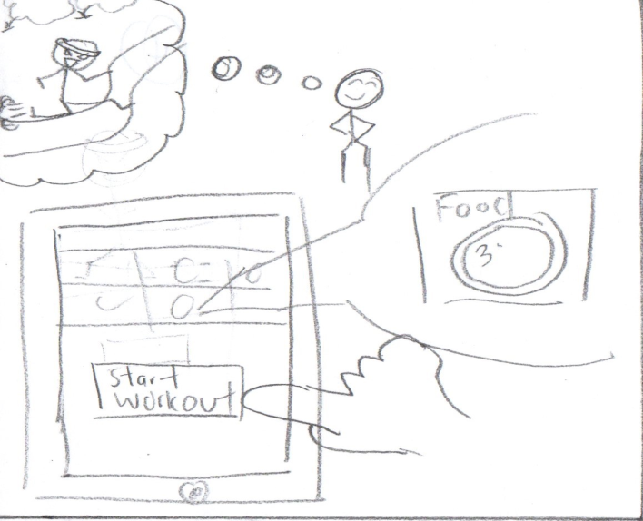

1. Student wish to start exercising using the FitHealth application. The student selects the start workout

4.If the student selects distance workout goal, the app displays a screen that allows the student to set the distance goal. Once the student is ready, he/she press start to begin workout . The app sends a signal to beep and display onscreen start on the wristband.

2.The app then displays the page to setup a workout. After student selects the workout goal type and workout type, the student has to submit to the app.

5.If the student selects calorie workout goal, the app displays a screen that allows the student to set the calories goal. Once the student is ready, he/she press start to begin workout . The app sends a signal to beep and display onscreen start on the wristband.

3.If the student selects time workout goal, the app displays a screen that allows the student to set the time goal. Once the student is ready, he/she press start to begin workout . The app sends a signal to beep and display onscreen start on the wristband

6. After completing the workout, the application displays the summary of the workout.. At the same time, the tablet signals the wristband to vibrate and display onscreen “end” .

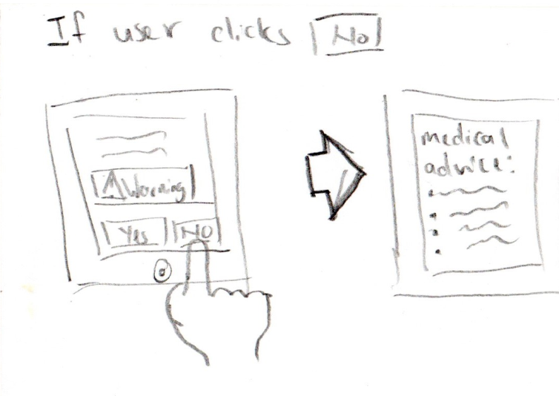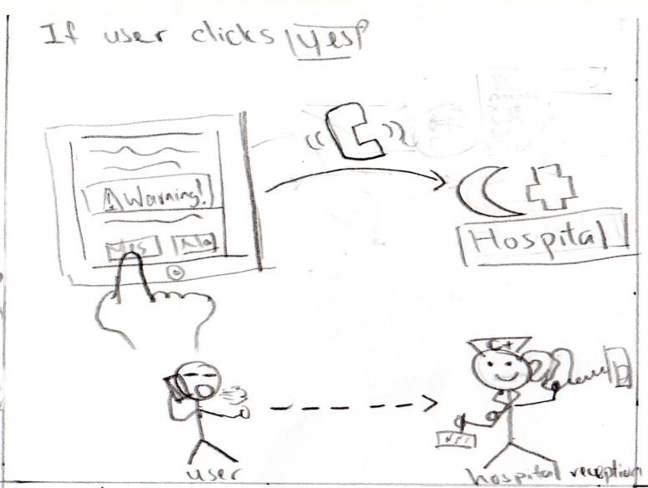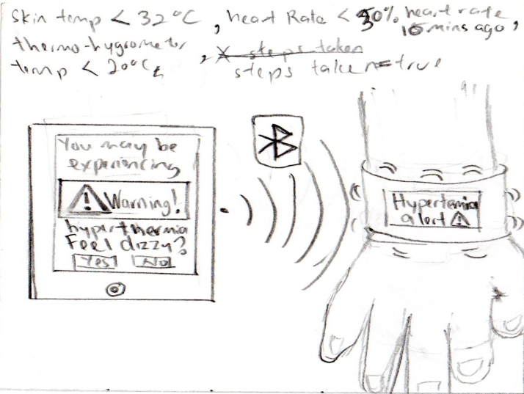S

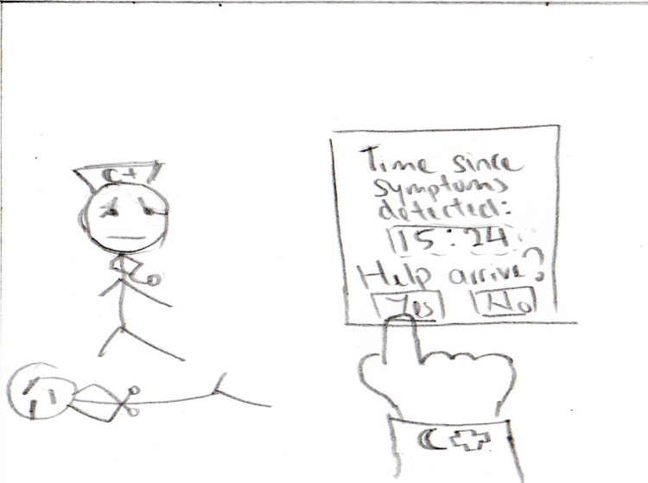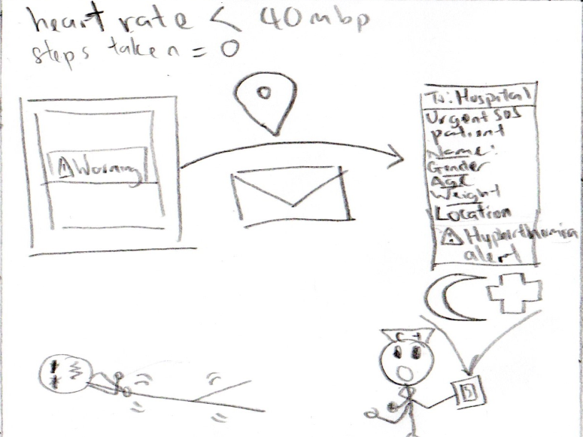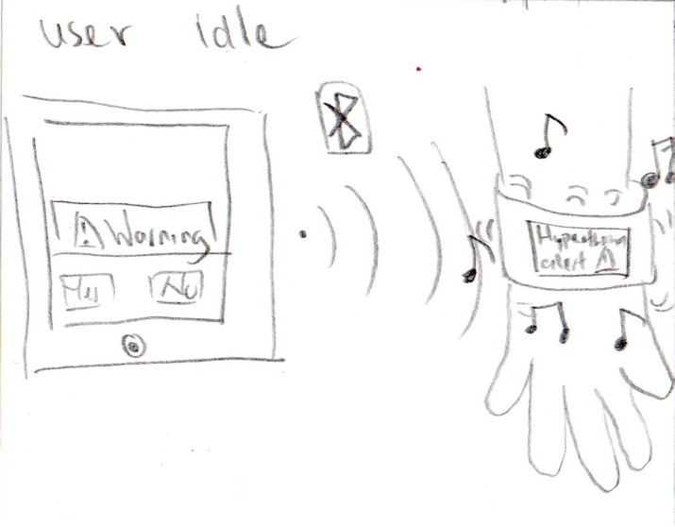1.During Semester break, student went climbing a snow capped mountain of Hkakabo Razi,Myanmar . Student while climbing fell ill. The skin temperature is lower than 32 Celsius, heart rate decreased by 30% and the thermos-hygrometer is lower than 20 Celsius. A warning pops out and user is prompted to identify if student feels dizzy.

4. If the student did not give a response to the app in 5 minutes, then it will signal the wristband to vibrate, play a tune and display “hyperthermia warning”

2.The student does feel dizzy and selects yes. The app will automatically call the number of the nearest hospital

5. While climbing the mountain, the student fainted from hyperthermia. If no steps are taken and heart rate slows down to 40 mbp, the app will send a message to the closest hospital the student details and location.

3.If the student does not feel dizzy and selects no, a medical advice analysis by FitHealth would be displayed.

6. The hospital attendant arrives on the scene and treats the student. The hospital attendant also confirms his/her presence on the tab as the app displays the timer of the time since the skin temperature is lower than 32 Celsius, heart rate decreased by 30% and the thermos-hygrometer is lower than 20 Celsius